

|  |  |  |  |  |  |
| --- | --- | --- | --- | --- | --- |
| Programme | : | **BTech. CSE Core** | Semester | : | **Win 2021-22** |
| Course | : | **Microprocessor and Interfacing** | Code | : | **CSE2006** |
| Faculty | : | **Dr. Florence Gnana Poovathy J** | Slot | : | **L15+L16** |
| Name | : | **Hariket Sukesh Kumar Sheth** | Register No. | : | **20BCE1975** |

**Experiment 1:**Arithmetic Operations (Addition, Subtraction, Multiplication, Division) on 8-Bit and 16-Bit Numbers

**1**

|  |  |  |  |
| --- | --- | --- | --- |
| Date: 12-01-2022 | Exp. 01 | Arithmetic Operations |  |

**Addition (8 bit)**

**Aim:** To Perform Addition of 8-Bit Numbers

**Algorithm:**

**Step 1:** Mount the c drive using the command: **mount c c:\masm611\bin**

**Step 2:** Press **Enter,** Type **c:** to switch from z: to c: drive.

**Step 3:** Enter the command **edit add8.asm** for writing/editing the code.

**Step 4:** A pop window appears, write your code(instructions) there for Addition of 8-Bit Numbers.

1. Start.
2. Let CS is Code and DS is Data.
3. Code Segment starts.
4. Move Data to AL.
5. Move Data to BL.
6. Add Data of AL and BL.
7. Code Segment ends.
8. End.

**Step 5:** Save the Code, and exit the editor. Type the command **masm add8.asm** for running the code. The object file is created.

**Step 6:** Next, Type the command **link add8.obj;** to link the object file to library file present in the bin folder.

**Step 7:** Type **debug add8.exe** to execute the code.

**-u**

**-g 0764:0006** to view the result in all the registers specifically at that HLT Position.

(-g <Address of HLT Command>)

We check here the value stored in **AX register** which is the result obtained after addition of values in AL and BL registers.

**2**

**Program:**

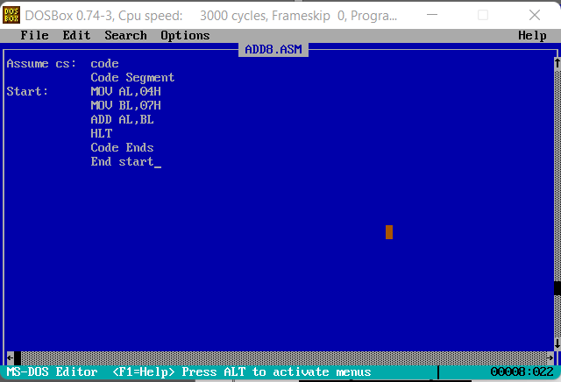

|  |  |
| --- | --- |
| **Sample Input:** | **Sample Output:** |
| AL= 04H  BL= 07H | AL=AL+BL  AL=04H+07H=0BH  Hence, AX=FF0B |

**Register / Memory Contents for I/O:**

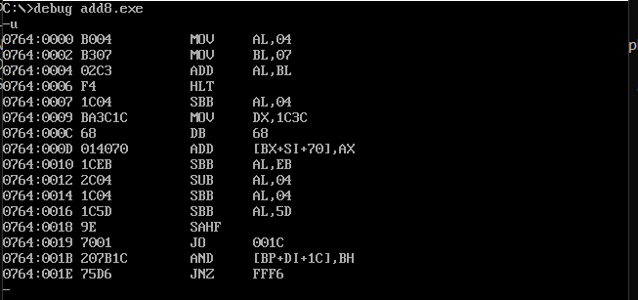

**3**

**Output:**

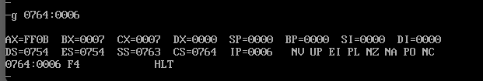

|  |  |  |  |
| --- | --- | --- | --- |
| Date: 12-01-2022 | Exp. 01 | Arithmetic Operations |  |

**Addition (16 bit)**

**Aim:** To Perform Addition of 16-Bit Numbers

**Algorithm:**

**Step 1:** Mount the c drive using the command: **mount c c:\masm611\bin**

**Step 2:** Press **Enter,** Type **c:** to switch from z: to c: drive.

**Step 3:** Enter the command **edit add16.asm** for writing/editing the code.

**Step 4:** A pop window appears, write your code(instructions) there for Addition of 16-Bit Numbers.

1. Start.
2. Let CS is Code and DS is Data.
3. Code Segment starts.
4. Move Data to AX.
5. Move Data to BX.
6. Add Data of AX and BX.
7. Code Segment ends.
8. End.

**Step 5:** Save the Code, and exit the editor. Type the command **masm add16.asm** for running the code. The object file is created.

**Step 6:** Next, Type the command **link add16.obj;** to link the object file to library file present in the bin folder.

**Step 7:** Type **debug add16.exe** to execute the code.

**-u**

**-g 0764:0008** to view the result in all the registers specifically at that HLT Position.

(-g <Address of HLT Command>)

We check here the value stored in **AX register** which is the result obtained after addition of values in AX and BX registers.

**4**

**Program:**

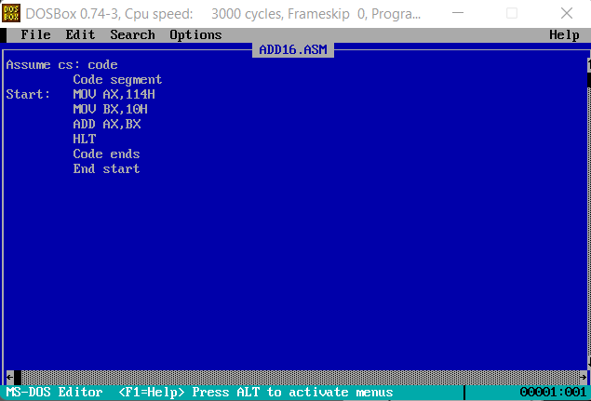

|  |  |
| --- | --- |
| **Sample Input:** | **Sample Output:** |
| AX = 0114H  BX = 0010H | AX=AX+BX  AX=0114H+0010H=0124H  Hence, AX=0124 |

**Register / Memory Contents for I/O:**

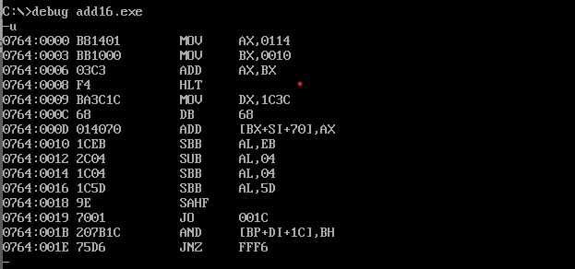

**Output:**

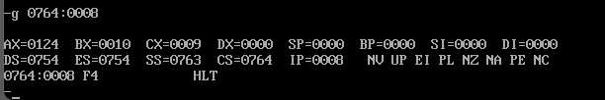

**5**

|  |  |  |  |
| --- | --- | --- | --- |
| Date: 12-01-2022 | Exp. 01 | Arithmetic Operations |  |

**Subtraction (8 bit)**

**Aim:** To Perform Subtraction of 8-Bit Numbers

**Algorithm:**

**Step 1:** Mount the c drive using the command: **mount c c:\masm611\bin**

**Step 2:** Press **Enter,** Type **c:** to switch from z: to c: drive.

**Step 3:** Enter the command **edit sub8.asm** for writing/editing the code.

**Step 4:** A pop window appears, write your code(instructions) there for Subtraction of 8-Bit Numbers.

* 1. Start.
  2. Let CS is Code and DS is Data.
  3. Code Segment starts.
  4. Move Data to AL.
  5. Move Data to BL.
  6. Subtract Data of AL and BL.
  7. Code Segment ends.
  8. End.

**Step 5:** Save the Code, and exit the editor. Type the command **masm sub8.asm** for running the code. The object file is created.

**Step 6:** Next, Type the command **link sub8.obj;** to link the object file to library file present in the bin folder.

**Step 7:** Type **debug sub8.exe** to execute the code.

**-u**

**-g 0764:0006** to view the result in all the registers specifically at that HLT Position.

(-g <Address of HLT Command>)

We check here the value stored in **AX register** which is the result obtained after subtraction of values in AL and BL registers.

**6**

**Program:**

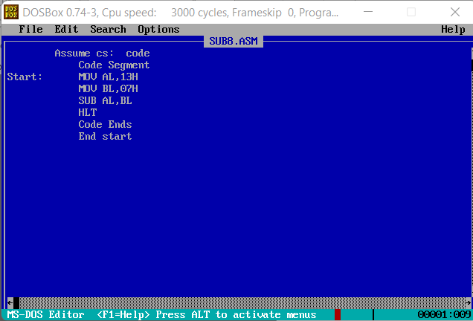

|  |  |
| --- | --- |
| **Sample Input:** | **Sample Output:** |
| AL= 13H = 192  BL= 07H = 72 | AL=AL-BL  AL=13H-07H=192 – 72 = 122 = 0CH  Hence, AX=FF0C |

**Register / Memory Contents for I/O:**

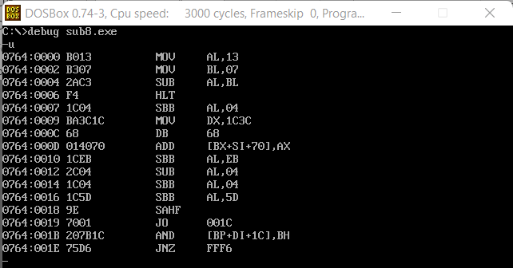

**7**

**Output:**

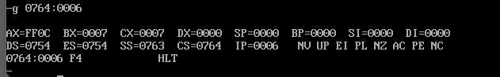

|  |  |  |  |
| --- | --- | --- | --- |
| Date: 12-01-2022 | Exp. 01 | Arithmetic Operations |  |

**Subtraction (16 bit)**

**Aim:** To Perform Subtraction of 16-Bit Numbers

**Algorithm:**

**Step 1:** Mount the c drive using the command: **mount c c:\masm611\bin**

**Step 2:** Press **Enter,** Type **c:** to switch from z: to c: drive.

**Step 3:** Enter the command **edit sub16.asm** for writing/editing the code.

**Step 4:** A pop window appears, write your code(instructions) there for Subtraction of 16-Bit Numbers.

* 1. Start.
  2. Let CS is Code and DS is Data.
  3. Code Segment starts.
  4. Move Data to AX.
  5. Move Data to BX.
  6. Subtract Data of AX and BX.
  7. Code Segment ends.
  8. End.

**Step 5:** Save the Code, and exit the editor. Type the command **masm sub16.asm** for running the code. The object file is created.

**Step 6:** Next, Type the command **link sub16.obj;** to link the object file to library file present in the bin folder.

**Step 7:** Type **debug sub16.exe** to execute the code.

**-u**

**-g 0764:0008** to view the result in all the registers specifically at that HLT Position.

(-g <Address of HLT Command>)

**8**

We check here the value stored in **AX register** which is the result obtained after subtraction of values in AX and BX registers.

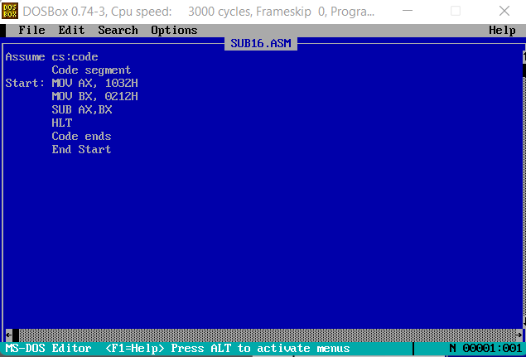**Program:**

|  |  |
| --- | --- |
| **Sample Input:** | **Sample Output:** |
| AX = 1032H = 41462  BX = 0212H = 5302 | AX=AX-BX  AX=1032H-0212H= 41462 – 5302 = 3616­2 = 0E20H  Hence, AX=0E20 |

**Register / Memory Contents for I/O:**

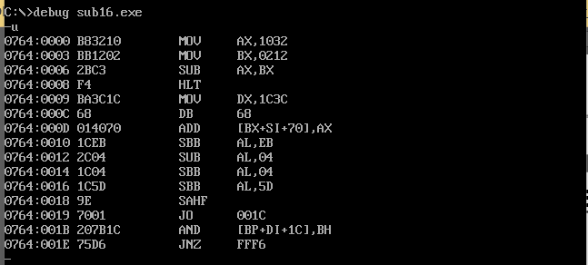

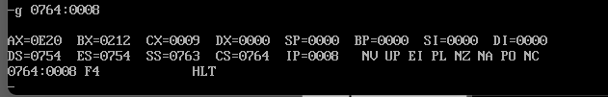**Output:**

**9**

|  |  |  |  |
| --- | --- | --- | --- |
| Date: 12-01-2022 | Exp. 01 | Arithmetic Operations |  |

**Multiplication (8 bit)**

**Aim:** To Perform Multiplication of 8-Bit Numbers

**Algorithm:**

**Step 1:** Mount the c drive using the command: **mount c c:\masm611\bin**

**Step 2:** Press **Enter,** Type **c:** to switch from z: to c: drive.

**Step 3:** Enter the command **edit mul8.asm** for writing/editing the code.

**Step 4:** A pop window appears, write your code(instructions) there for Multiplication of 8-Bit Numbers.

* 1. Start.
  2. Let CS is Code and DS is Data.
  3. Code Segment starts.
  4. Move Data to AL.
  5. Move Data to BL.
  6. Multiply Data of AL and BL.
  7. Code Segment ends.
  8. End.

**Step 5:** Save the Code, and exit the editor. Type the command **masm mul8.asm** for running the code. The object file is created.

**Step 6:** Next, Type the command **link mul8.obj;** to link the object file to library file present in the bin folder.

**Step 7:** Type **debug mul8.exe** to execute the code.

**-u**

**-g 0764:0006** to view the result in all the registers specifically at that HLT Position.

(-g <Address of HLT Command>)

**10**

We check here the value stored in **AX register** which is the result obtained after multiplication of values in AL and BL registers.

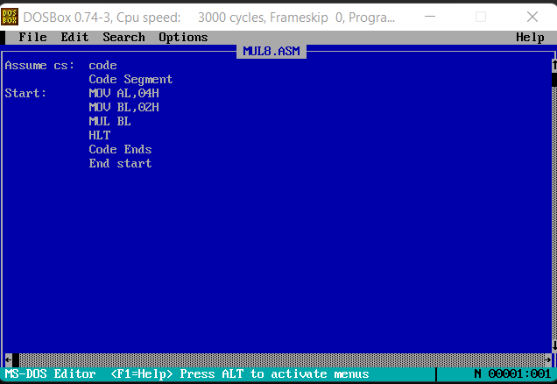**Program:**

|  |  |
| --- | --- |
| **Sample Input:** | **Sample Output:** |
| AL= 04H  BL= 02H | AL=AL*BL  AL=04H * 02H = 08H  Hence, AX=0008 |

**Register / Memory Contents for I/O:**

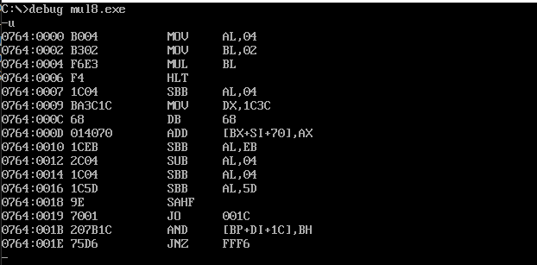

**11**

**Output:**

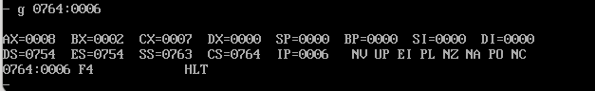

|  |  |  |  |
| --- | --- | --- | --- |
| Date: 12-01-2022 | Exp. 01 | Arithmetic Operations |  |

**Multiplication (16 bit)**

**Aim:** To Perform Multiplication of 16-Bit Numbers

**Algorithm:**

**Step 1:** Mount the c drive using the command: **mount c c:\masm611\bin**

**Step 2:** Press **Enter,** Type **c:** to switch from z: to c: drive.

**Step 3:** Enter the command **edit mul16.asm** for writing/editing the code.

**Step 4:** A pop window appears, write your code(instructions) there for Multiplication of 16-Bit Numbers.

* 1. Start.
  2. Let CS is Code and DS is Data.
  3. Code Segment starts.
  4. Move Data to AX.
  5. Move Data to BX.
  6. Multiply Data of AX and BX.
  7. Code Segment ends.
  8. End.

**Step 5:** Save the Code, and exit the editor. Type the command **masm mul16.asm** for running the code. The object file is created.

**Step 6:** Next, Type the command **link mul16.obj;** to link the object file to library file present in the bin folder.

**Step 7:** Type **debug mul16.exe** to execute the code.

**-u**

**-g 0764:0008** to view the result in all the registers specifically at that HLT Position.

(-g <Address of HLT Command>)

**12**

We check here the value stored in **AX register** which is the result obtained after multiplication of values in AX and BX registers.

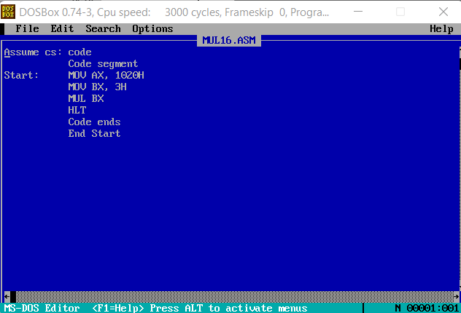**Program:**

|  |  |
| --- | --- |
| **Sample Input:** | **Sample Output:** |
| AX = 1020H  BX = 0003H | AX=AX*BX  AX=1020*3 = 3060H  Hence, AX=3060 |

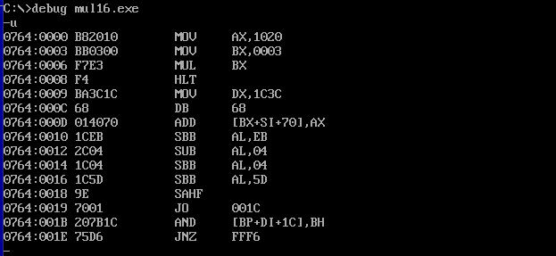**Register / Memory Contents for I/O:**

**Output:**

**13**

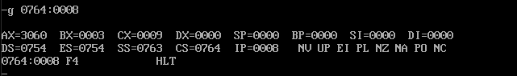

|  |  |  |  |
| --- | --- | --- | --- |
| Date: 12-01-2022 | Exp. 01 | Arithmetic Operations |  |

**Division (8 bit)**

**Aim:** To Perform Division of 8-Bit Numbers

**Algorithm:**

**Step 1:** Mount the c drive using the command: **mount c c:\masm611\bin**

**Step 2:** Press **Enter,** Type **c:** to switch from z: to c: drive.

**Step 3:** Enter the command **edit div8.asm** for writing/editing the code.

**Step 4:** A pop window appears, write your code(instructions) there for Division of 8-Bit Numbers.

* 1. Start.
  2. Let CS is Code and DS is Data.
  3. Code Segment starts.
  4. Move Data to AL.(00 to AH)
  5. Move Data to BL.
  6. Divide Data of AX and BL.
  7. Code Segment ends.
  8. End.

**Step 5:** Save the Code, and exit the editor. Type the command **masm div8.asm** for running the code. The object file is created.

**Step 6:** Next, Type the command **link div8.obj;** to link the object file to library file present in the bin folder.

**Step 7:** Type **debug div8.exe** to execute the code.

**-u**

**-g 0764:0007** to view the result in all the registers specifically at that HLT Position.

(-g <Address of HLT Command>)

We check here the value stored in **AX register** which is the result obtained after division of values in AL and BL registers.

**14**

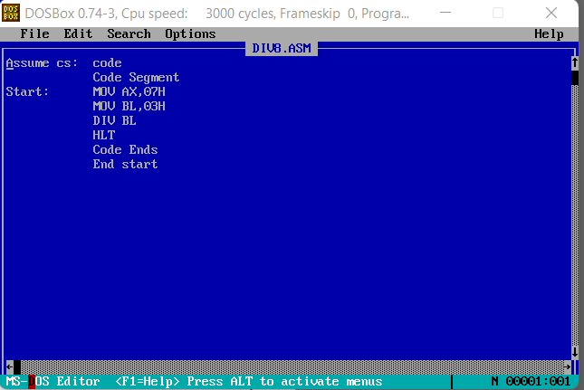**Program:**

|  |  |
| --- | --- |
| **Sample Input:** | **Sample Output:** |
| AX= 07H  BL= 03H | AX = AX/BL  Remainder(AH) = 01; Quotient(AL) = 02  Hence, AX=0102 |

**Register / Memory Contents for I/O:**

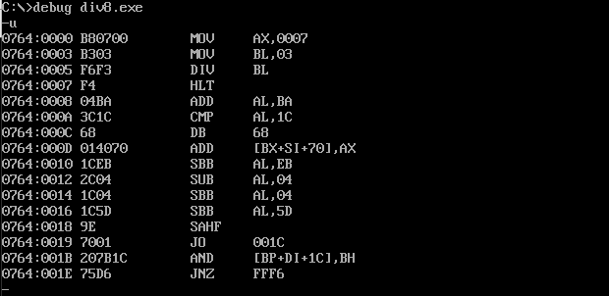

**15**

**Output:**

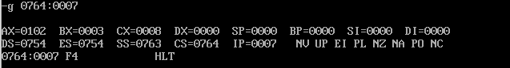

|  |  |  |  |
| --- | --- | --- | --- |
| Date: 12-01-2022 | Exp. 01 | Arithmetic Operations |  |

**Division (16 bit)**

**Aim:** To Perform Division of 16-Bit Numbers

**Algorithm:**

**Step 1:** Mount the c drive using the command: **mount c c:\masm611\bin**

**Step 2:** Press **Enter,** Type **c:** to switch from z: to c: drive.

**Step 3:** Enter the command **edit div16.asm** for writing/editing the code.

**Step 4:** A pop window appears, write your code(instructions) there for Division of 16-Bit Numbers.

* 1. Start.
  2. Let CS is Code and DS is Data.
  3. Code Segment starts.
  4. Move Data to AX.
  5. Move Data to BX.
  6. Divide Data of AX and BX.
  7. Code Segment ends.
  8. End.

**Step 5:** Save the Code, and exit the editor. Type the command **masm div16.asm** for running the code. The object file is created.

**Step 6:** Next, Type the command **link div16.obj;** to link the object file to library file present in the bin folder.

**Step 7:** Type **debug div16.exe** to execute the code.

**-u**

**-g 0764:0008** to view the result in all the registers specifically at that HLT Position.

(-g <Address of HLT Command>)

**16**

We check here the value stored in **AX register** which is the result obtained after division of values in AX and BX registers.

**Program:**

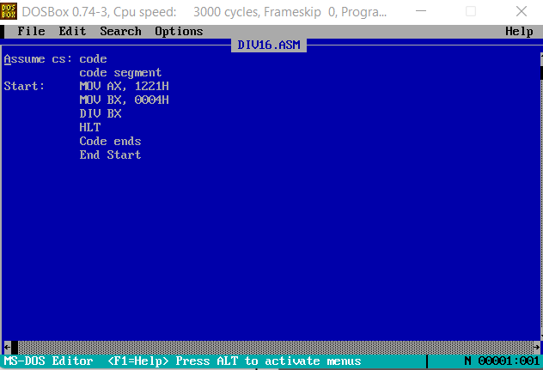

|  |  |
| --- | --- |
| **Sample Input:** | **Sample Output:** |
| AX = 1221H = 46412  BX = 0004H = 42 | AX=AX/BX  AX=4641/4 = 11602 = 0488H  Remainder: DX = 0001H  Hence, AX=0488H; DX=0001H |

**Register / Memory Contents for I/O:**

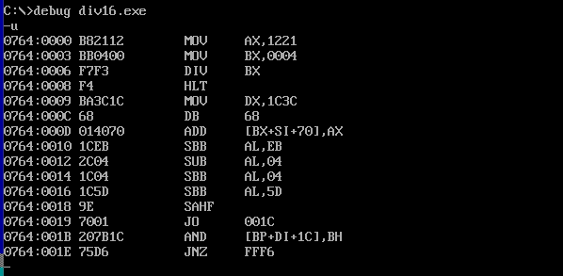

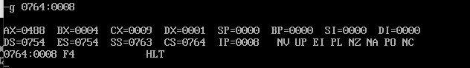**Output:**

**17**

**Result:** The arithmetic operations are performed in accordance with the calculated values. The assembly code functions as expected